Dashboard: Quick veiw of the status of the system. Allows the user to customize their view to provide the data that they are interested in seeing.

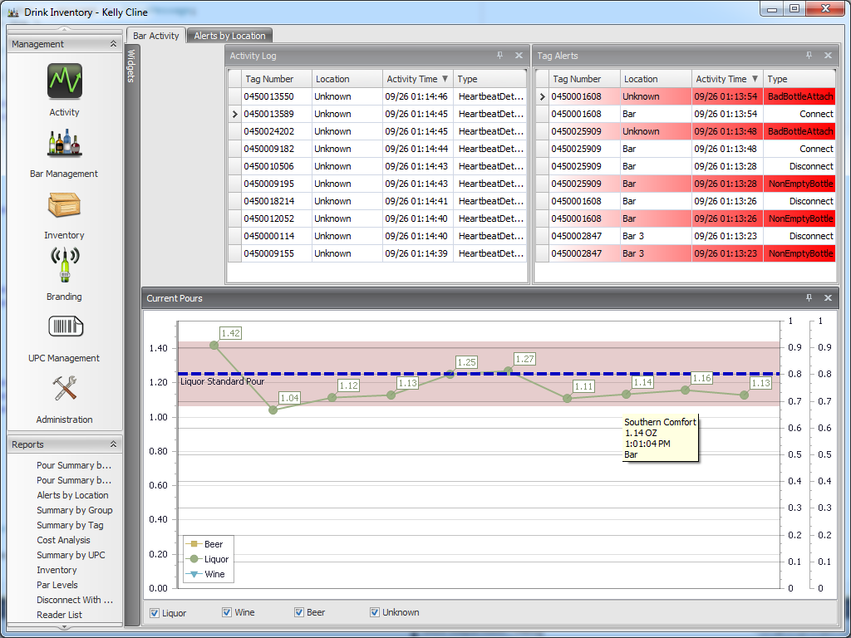

UPC Management: Allows users to quickly view their UPC collection an easily manage that collection.

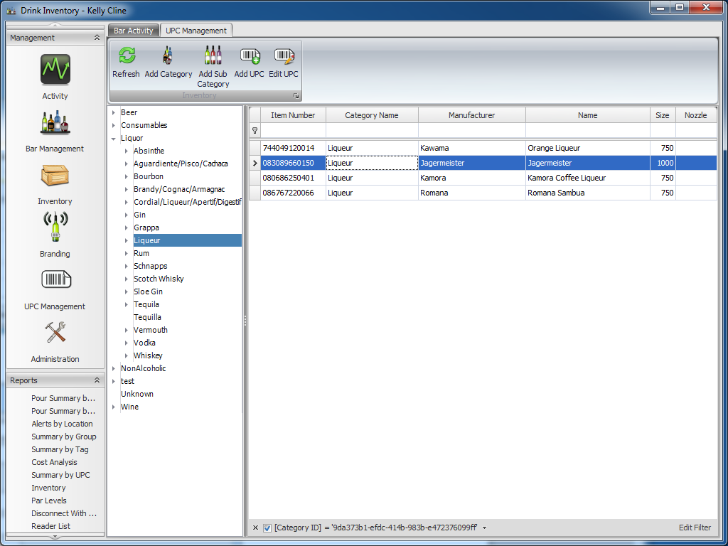

Add/Edit UPC’s:

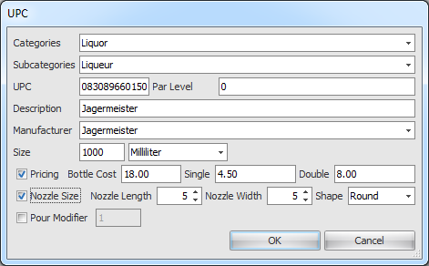

Branding: Used for associating a tag with a bottle. Allows for custom settings for nozzles and levels in the bottle at the time it is branded.

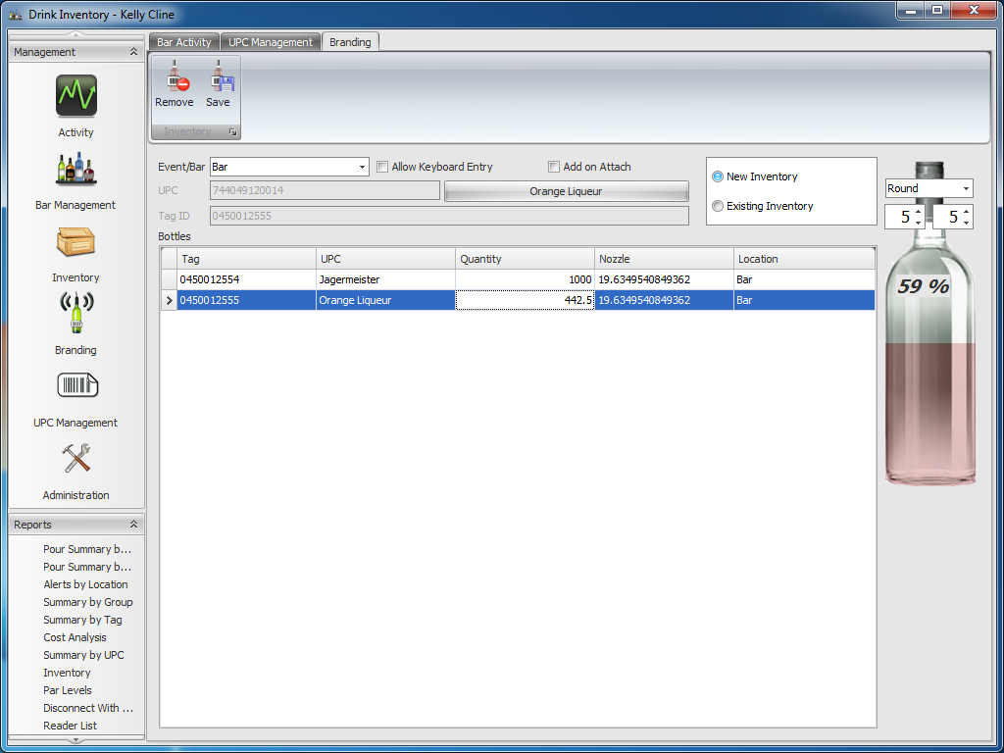

Inventory Management: Quick view of inventory at the specific locations for an establishment.

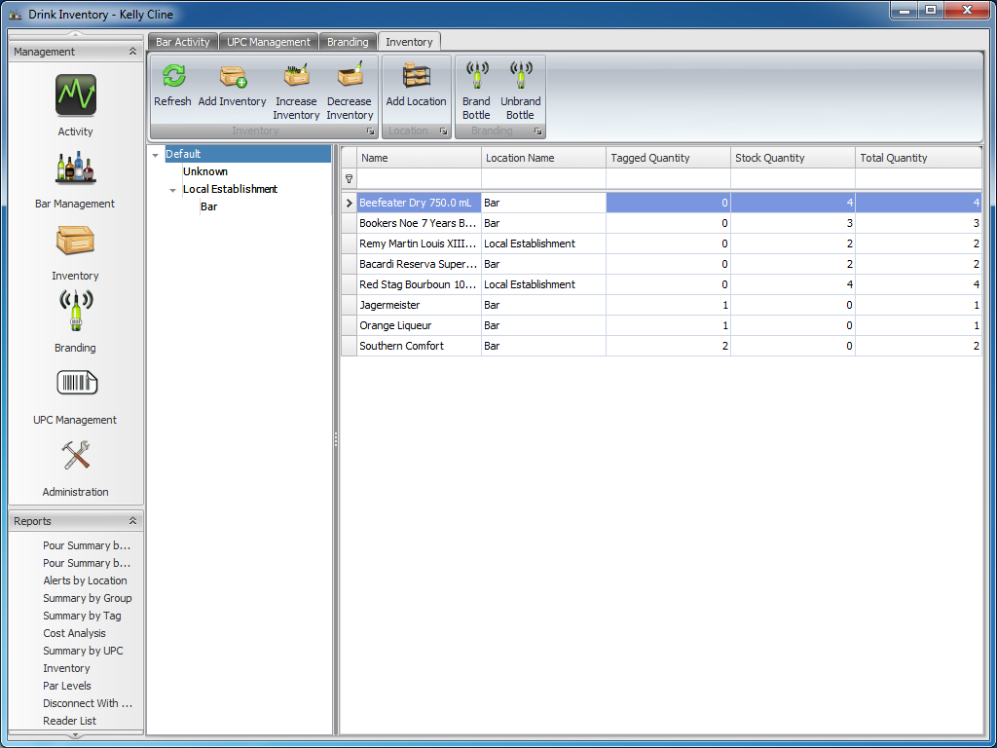

Adding Inventory: Allows for untagged inventory to be added to specific loations.

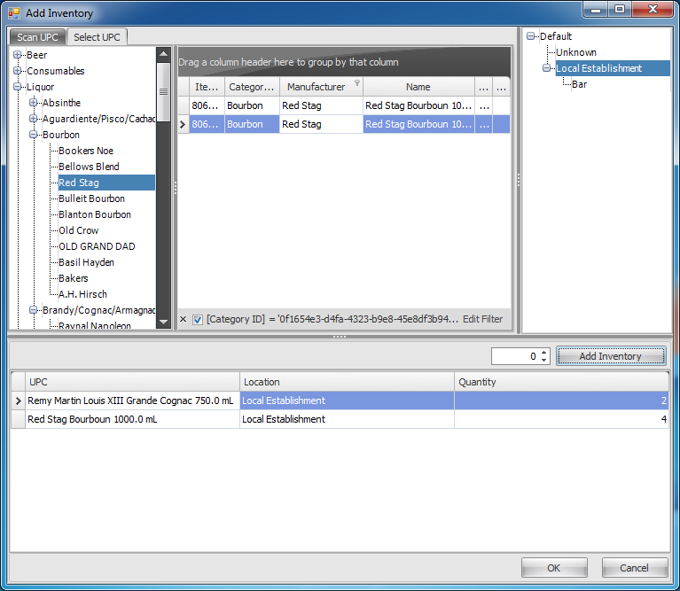

Bar Management: Allows for manually moving product from one location to another.

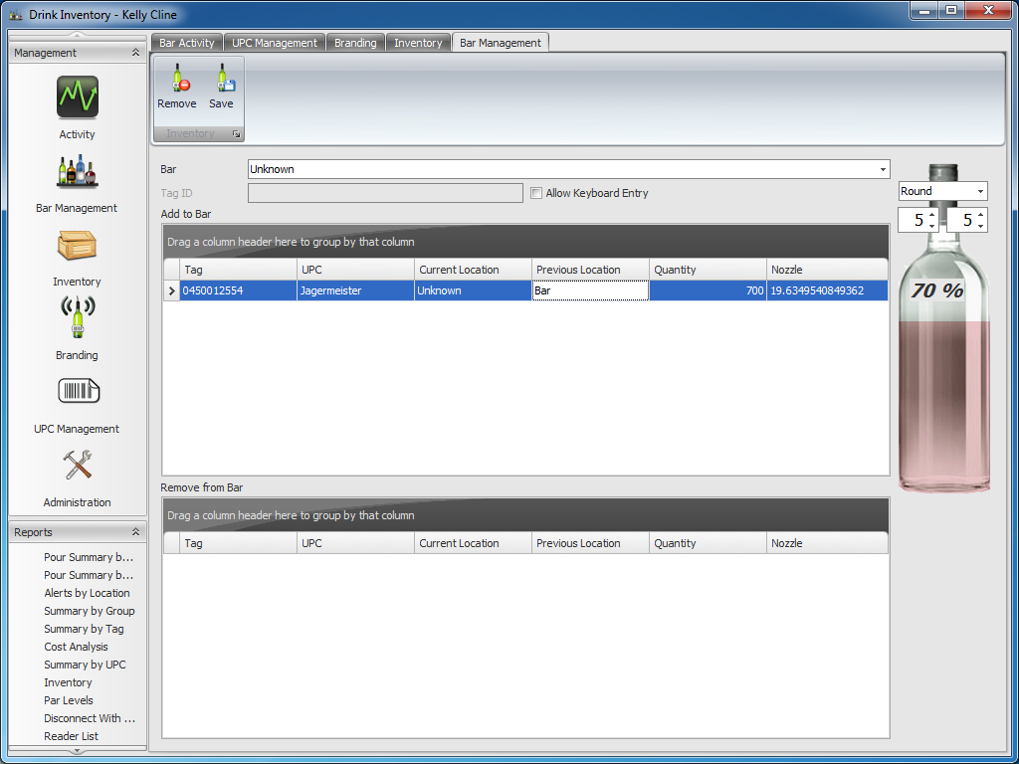

Simple Reporting: Allows for quick views of data in a “spreadsheet” style format.

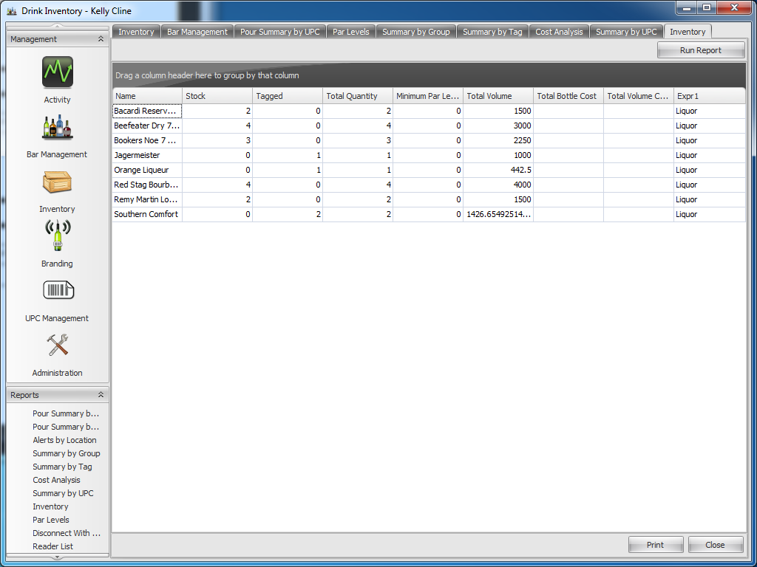

Simple Reporting Printing: Allows for printing/exporting of the simple reports.

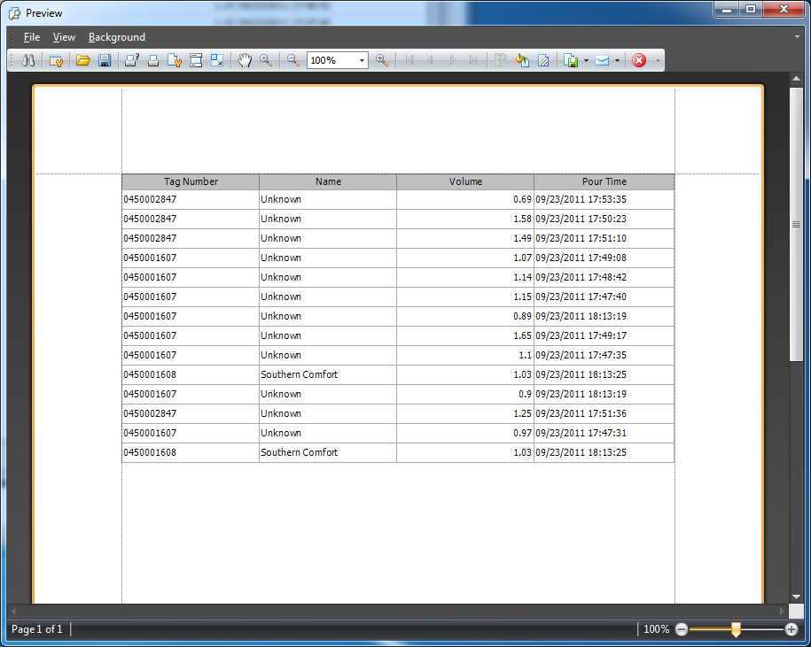

Enhanced Reports: Ability to view more enhanced reports that include charts/graphs.

